Proposal

The Idea behind my project is design a news application which lets you browse articles, and write your own.

The main features of this web application are, a connection to a REST news API that displays current news articles, with another component to add your own, which saves to a database and can then be viewed in a separate component, reading the data from said database.

I believe a user would find this interesting and fun because it takes the idea of a news application and personalises it like no other. Not only can you easily read news a nice, user friendly way, but you can add your own articles, almost like a more formal, official ‘tweet’ feature, but in an application strictly about news.

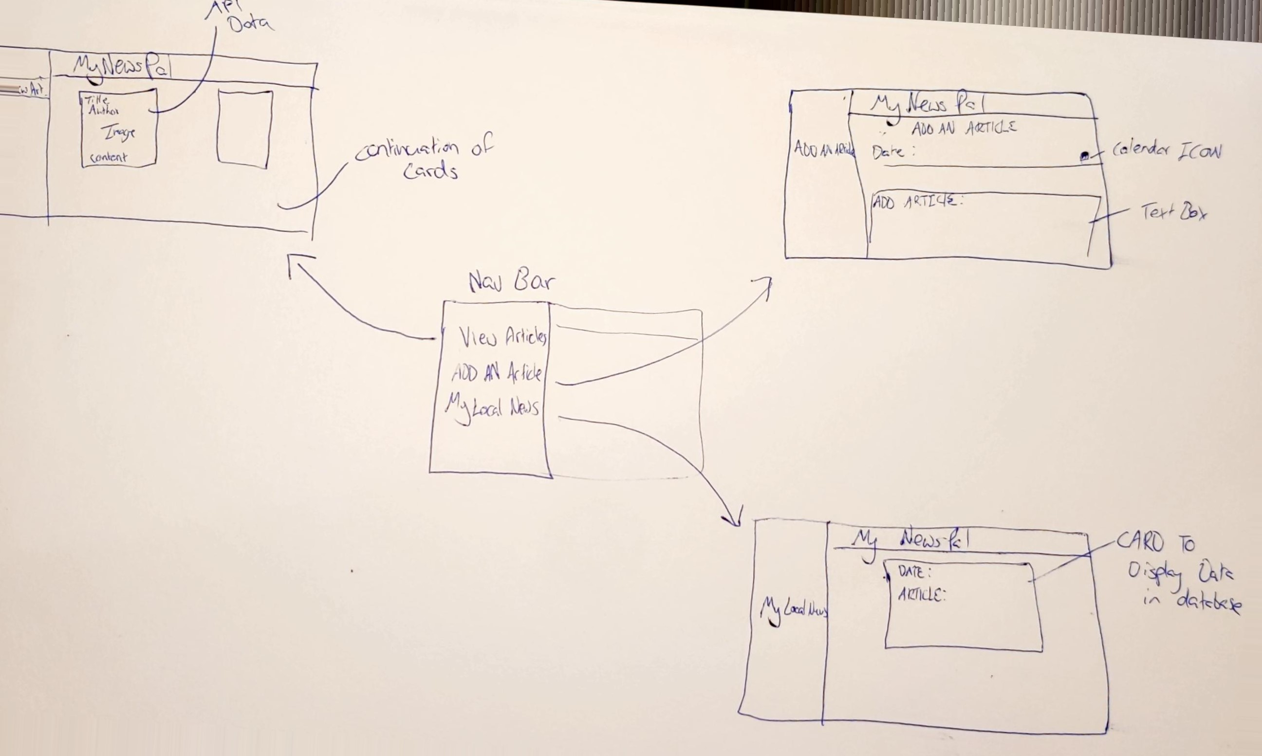

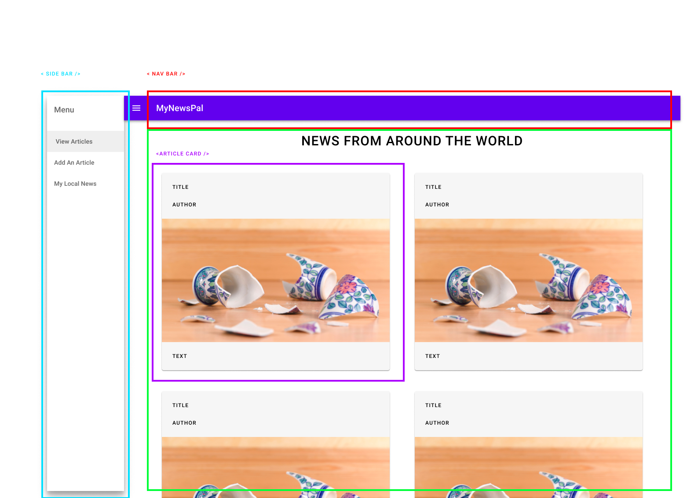

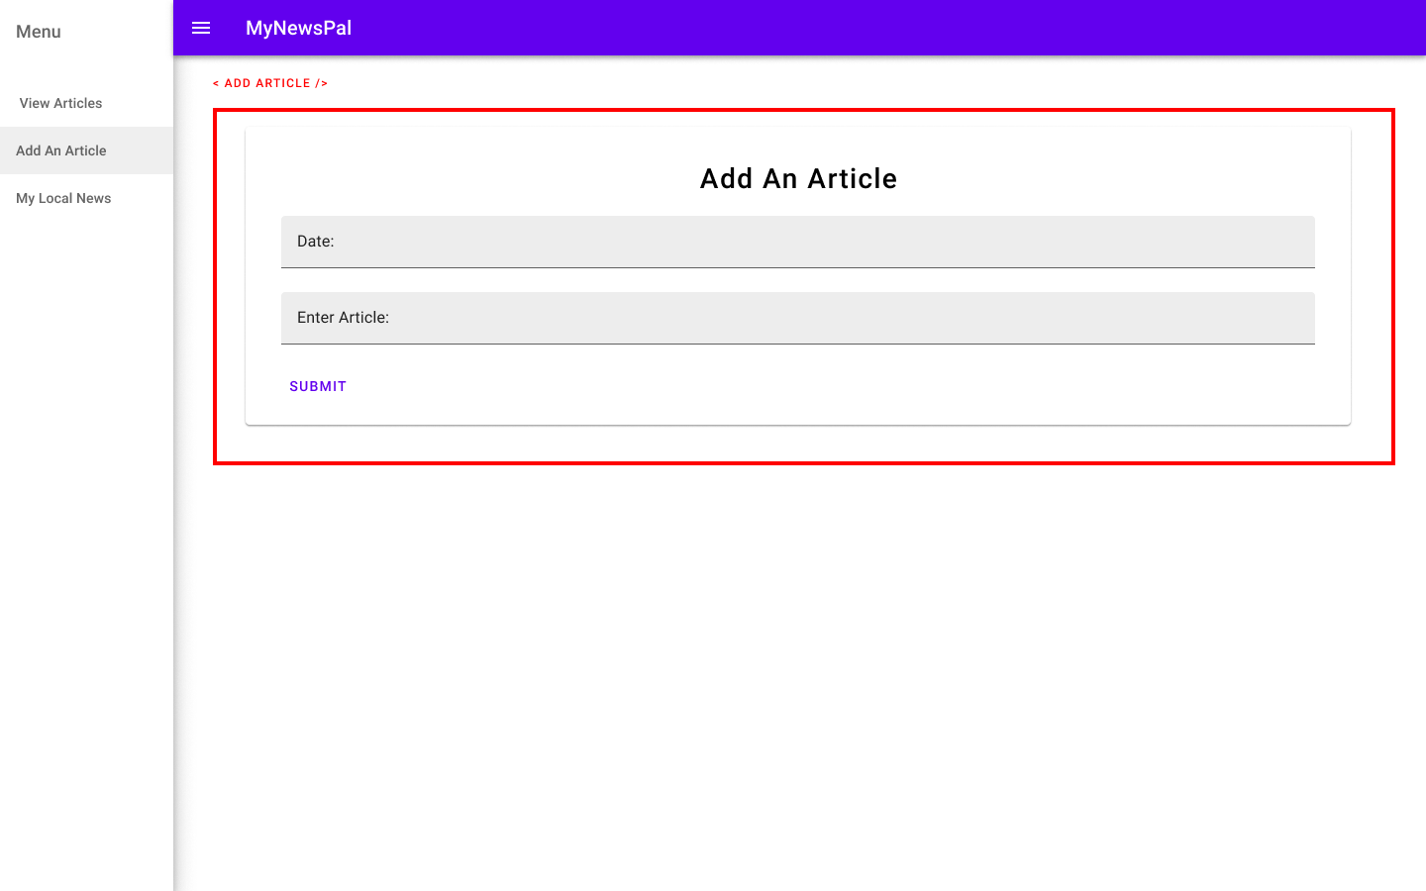

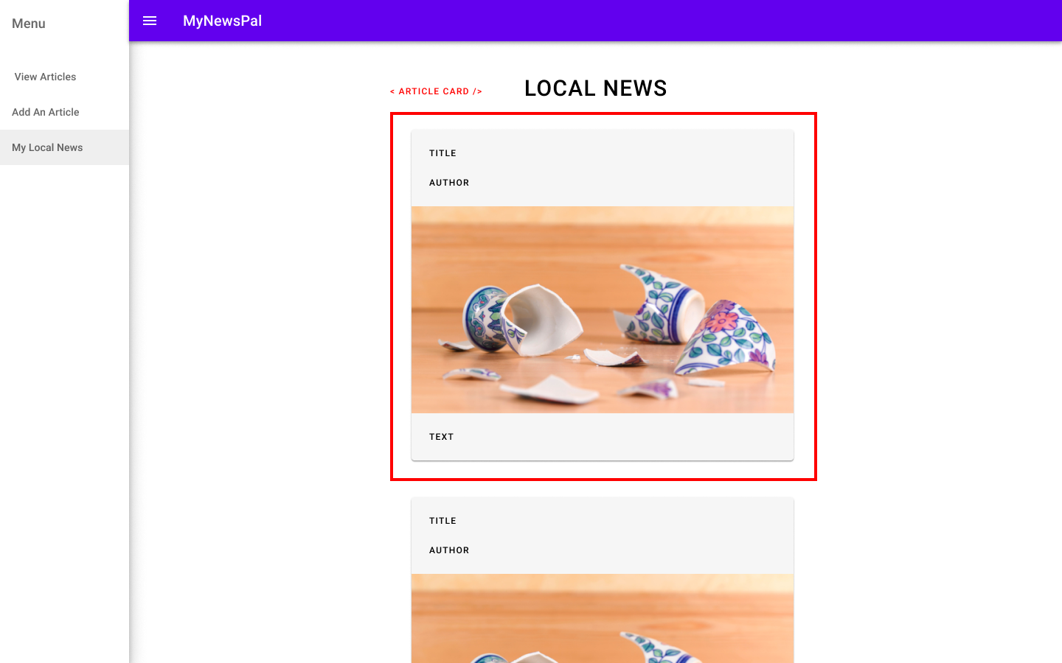

Report

Originally the design was quite basic, with the intention evolve.  


While crude and simple, this design allowed insight into how to further develop my project. By giving me a focus point and a source of paramount importance to rely on when design became messy or too intrinsic. This led to the neat and flush end design similar to what is seen below.



Component diagram below:

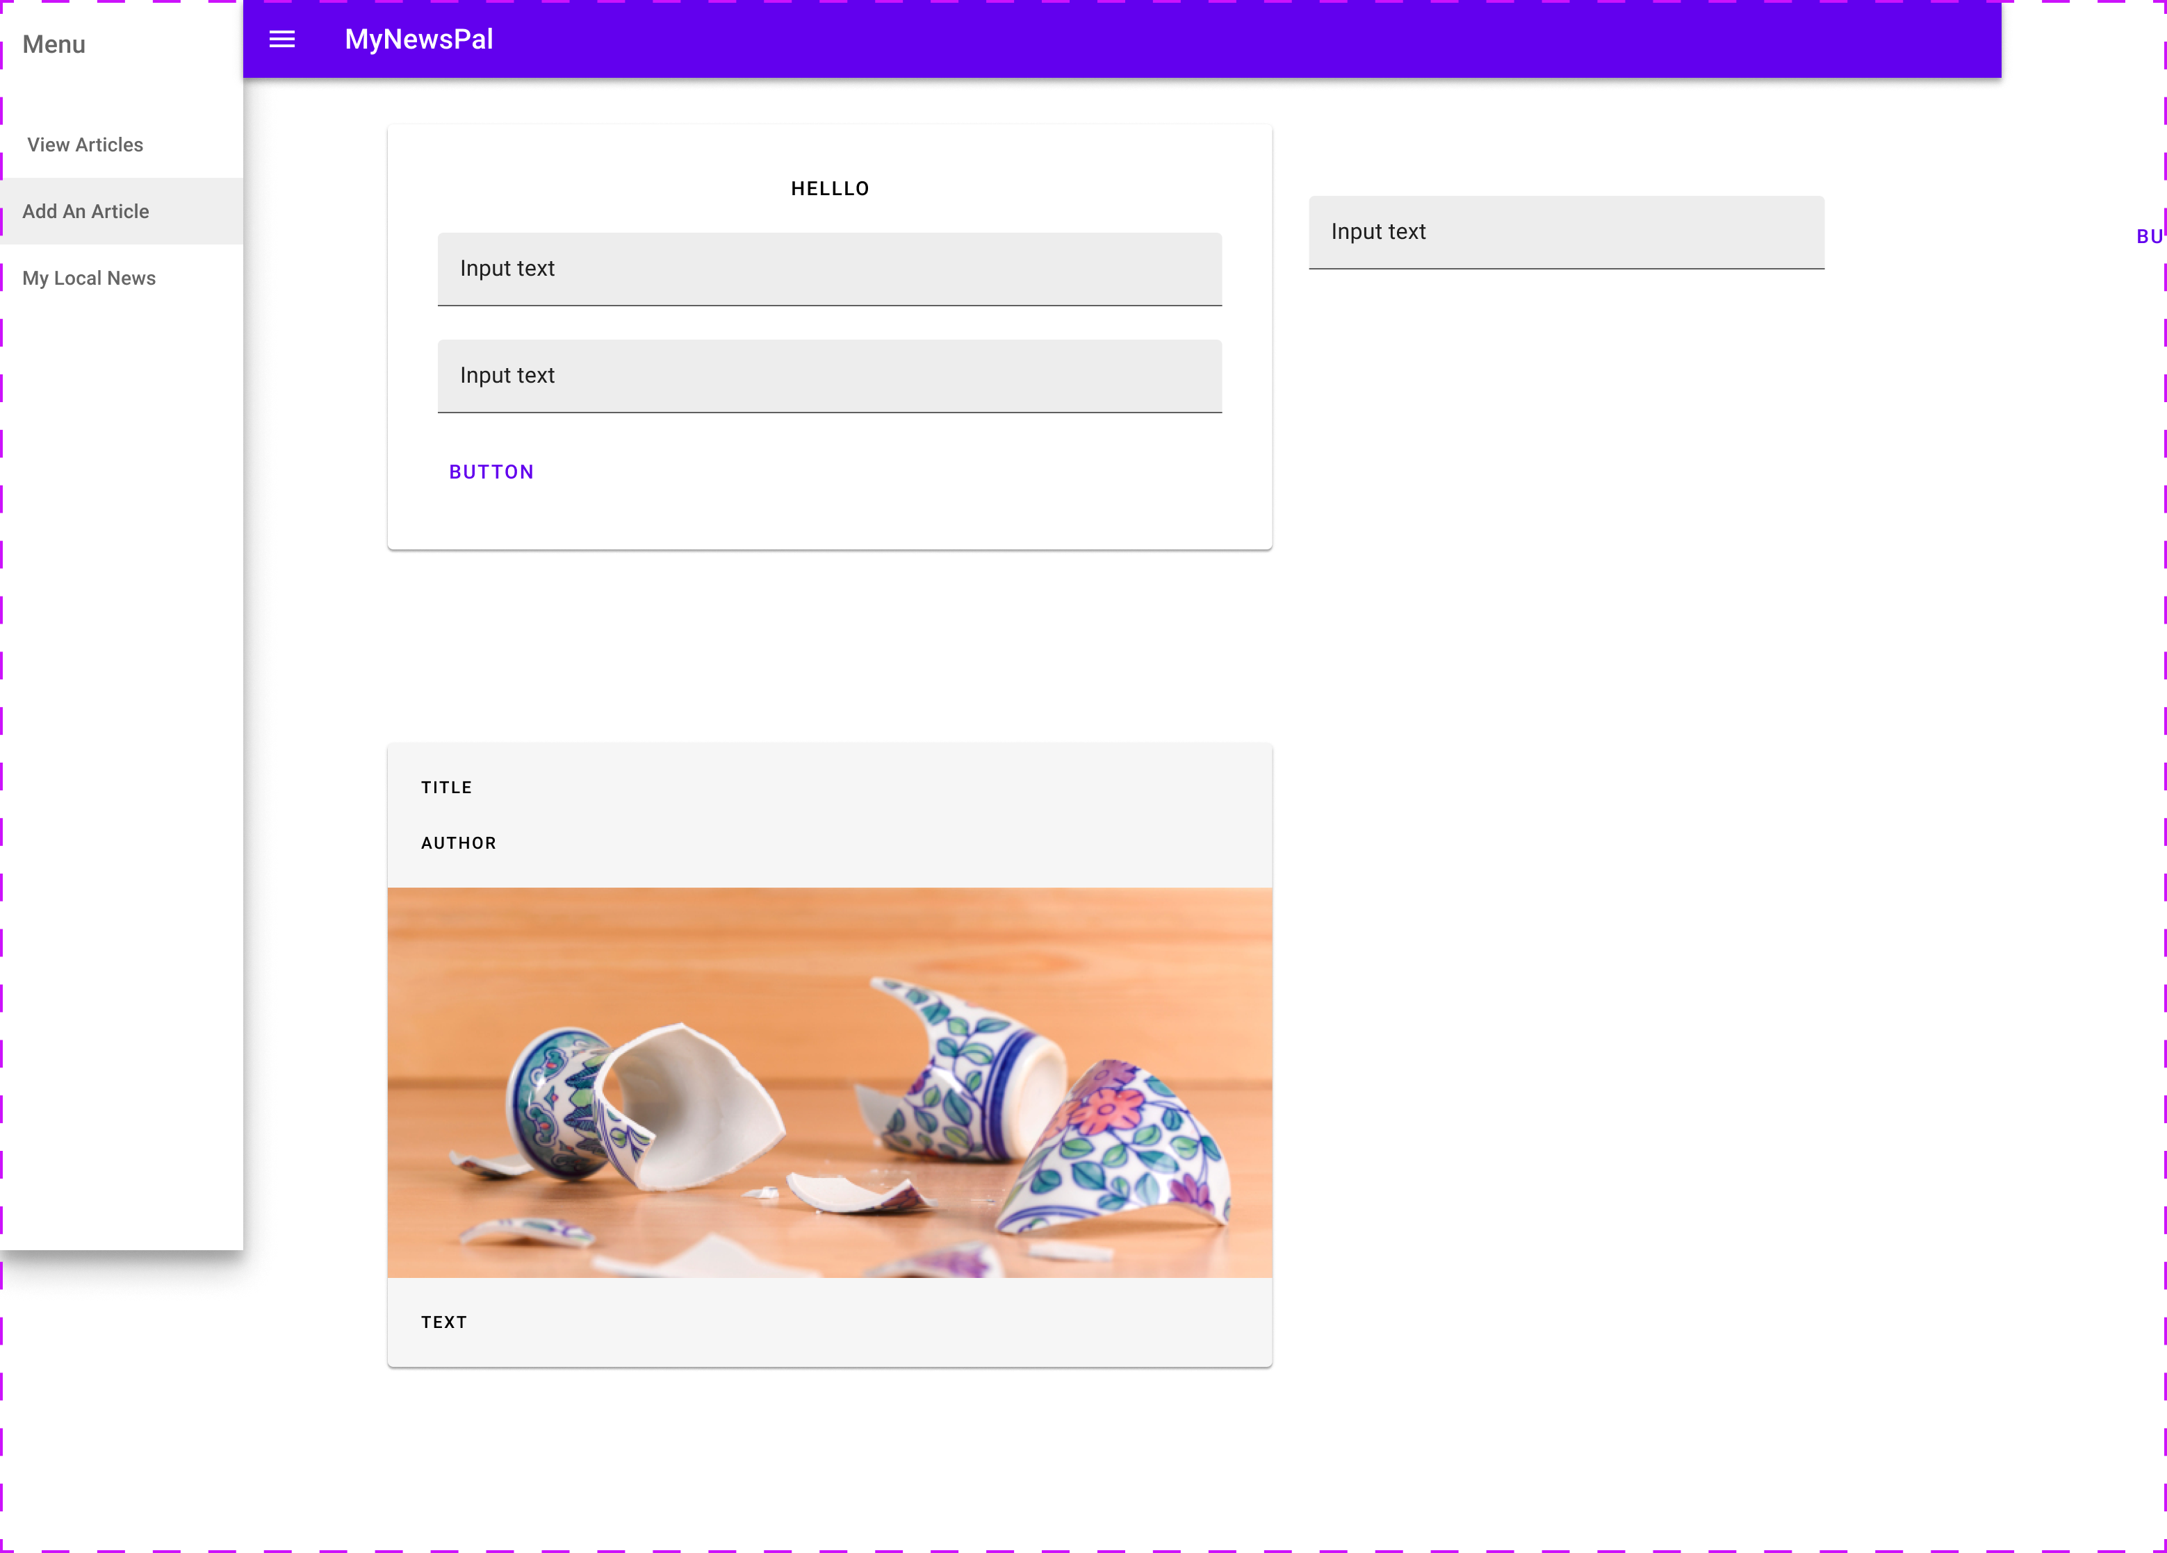

These are all the components used within my component. Cards used to display data, Nav bar to move through my components, form fields to enter data.

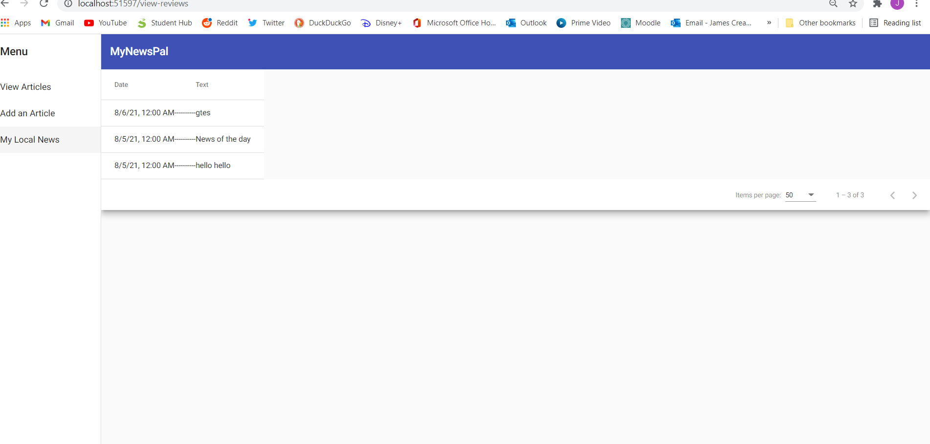

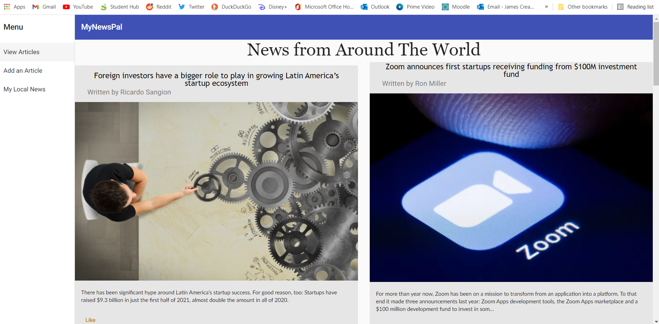

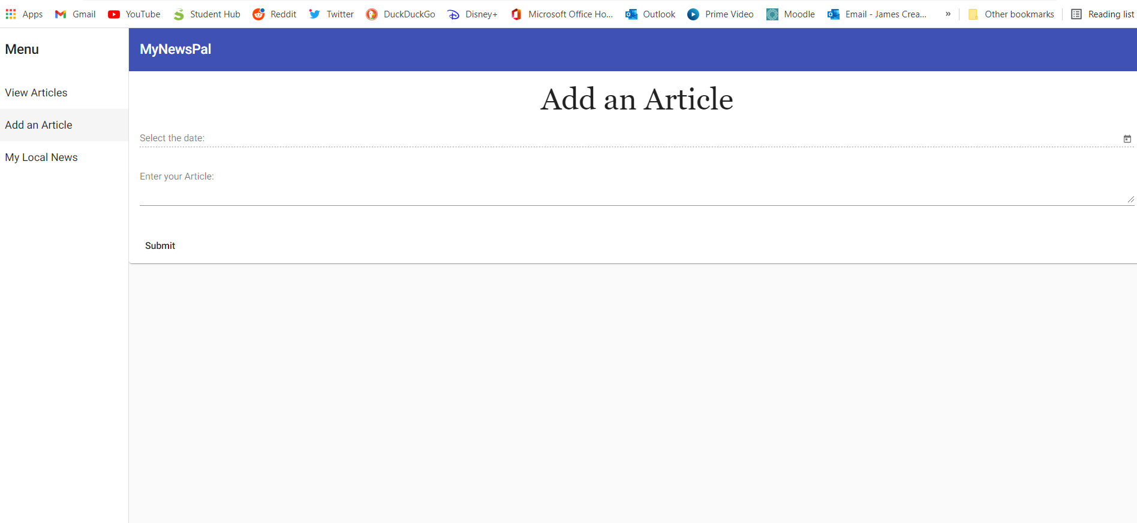

These screen grabs show the app in action. The three components can be seen, operating and fully styled.

The finished product here clearly shows the vast difference between it and the crude wireframes. Polished and operating efficiently, with the API sending an array of articles to be read, wrapped in a neat nav bar.

The css used for the nav bar is sleek and elegant, as is the case with the cards displayed in browse articles, and with various other components in different sections.

I have certainly learned a lot during the project. The key thing I have realised is persistence. Seldom have things ran smoothly for more than five minutes. Time, patience, and constant attempts was the only way to fix errors, and there were a lot. In recent days angular firebase received an update. It completely reworked the connection, leaving me lost confused. After countless attempts a came to solution and the database is once again fully operational. This shows the fluidity of this industry and once again, how time and patience are our key tools in designing applications.